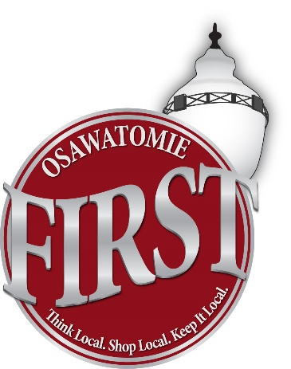
OSAWATOMIE CHAMBER OF COMMERCE
Think Local. Shop Local. Keep it Local.

509 5th Street, P.O. Box 63
Osawatomie, KS 66064
Phone (913) 755-4114
E-Mail: chamber@osawatomiechamber.org
Website: www.osawatomiechamber.org

Hello Potential Chamber Member!

My name is Hitomi Lamirande and I am the Executive Director for the Osawatomie Chamber of Commerce. I would like to take this opportunity to thank you for your presence within the Osawatomie Business Community and provide you with information about what we can offer to you as a new member of the Chamber of Commerce.
The Chamber works to strengthen and retain existing businesses, as well as attracting new businesses to the Osawatomie area. The Chamber offers a variety of ways to assist you in marketing your business as well as providing you with FREE business resources that can help you in your daily operations. The avenues in which the Chamber works with your business to reach these goals are as follows:

- The Chamber communicates news about upcoming chamber and community events through weekly e-mail blasts, Facebook and on-going communication with the Miami County Republic. We are happy to help you celebrate your Grand Opening or important anniversaries and milestones with a ribbon cutting, open house, or event of similar nature.

- The Chamber has developed a “shop at home” marketing campaign in the past several years to educate and encourage our residents to shop here and support you, the local businesses, that put your livelihoods on the line every day to support our community.

- The Chamber works closely with Miami County Economic Development, the Kansas Small Business Development Center and Kansas Department of Commerce. This provides a great opportunity to connect local businesses with services to assist them in their daily operating needs. Through these contacts, you can get personalized answers to questions and advice on growing your business. We also strive to keep you up to date on training opportunities offered throughout the year on a variety of topics to assist you in your day to day operations.

- The Osawatomie community and businesses are promoted by the Chamber in numerous ways including the Osawatomie Chamber website, weekly e-mail blasts, Facebook, a welcome packet for new residents, Annual Home & Business Expo, Chamber Buck Programs, The Holiday Festival, Spook Parade, special event fliers, and several other marketing events.

- A number of informal activities provide members the opportunity to exchange information and network. These events include Chamber Coffees, Multi-Chamber After Hours events, the Annual Membership Dinner, along with other get-togethers throughout the year.

- Members receive a Chamber Plaque to display with pride in their business designed to encourage citizens to shop locally and support your business.

- Members receive referrals from inquiries the Chamber receives.

- Members are included on the Chamber Website and can be linked to their business website as a marketing tool. This is vital in the age of technology. Many people search the internet prior to picking up a phone book.

- Members are encouraged to submit information, announcements, and special offers to the Chamber to be included in the weekly e-mail blast and monthly newsletter.

- Members can keep promotional items, flyers, business cards etc. in the Chamber Office. These marketing tools can be used in the Welcome Packets and also can be given to visitors at the Chamber.

- Members can schedule a Chamber Coffee at their place of business or at the Chamber Office. This type of networking helps you get acquainted with other members while bringing publicity to your business.

Studies show that the general public equates Chamber membership with better quality products and services, more trust, and they view members as being avid supporters of their communities. Our dues structure is very straightforward and has remained steady for several years.
Members are provided several payment options including quarterly and monthly payment plans and a 5% discount if paid in full by December 1st of each year. Our fiscal year runs November 1st through October 31st. For local businesses with less than five full time employees, membership works out to less than $15 per month! First year dues may also be pro-rated to reflect the remaining months of the year.
I welcome the opportunity to speak with you about Chamber membership at your convenience. The Chamber continues to grow and strengthen with every new member, and we would love to have YOU involved. We’re all in this together. Standing together as a community will only make us stronger.
Please feel free to contact me anytime with questions you may have. I look forward to speaking with you about the possibility of working together in the future.

Thank You,

Hitomi Lamirande
Executive Director
Osawatomie Chamber of Commerce

